## JAIPUR NATIONAL UNIVERISTY

## C:\Users\VIPOO\Desktop\14653894091460437591JNU.png SCHOOL OF ENGINEERING AND TECHNOLOGY

#### Project Development and Seminar

#### A Project Report On

**TOUR AND TRAVEL BUDDY**

**Bachelor of Technology (CSE)**

III Year (6th sem)

Submitted by: Submitted to:

Anjali Bothra Ms. Rachana Yadav

Ritika Kaushal Assistant Professor(SOET)

Yashi Audichya

## ABSTRACT

The purpose of the project entitled as "Travel Buddy" is a Java-based project designed to facilitate travelers in planning, organizing, and sharing their travel experiences. The project aims to provide a user-friendly platform where travelers can efficiently manage their itineraries, document their journeys, discover new destinations, and connect with fellow travelers. Traditionally, it was done manually. The main function of the system is register and store customer details and booking details and retrieve these details as and when required, and also to manipulate these details meaningfully System input contains customer details, package details, while system output is to get these details on to the screen. The Travel Management System can be entered using a username and password. It is accessible either by an administrator or Customer. Only they can add data into the database. The data can be retrieved easily. The data are well protected for personal use and makes the data processing very fast.

# Index

|  |  |  |
| --- | --- | --- |
| S.NO. | Topics | Page No. |
| 1 | INTRODUCTION | 4-7 |
| 2 | REQUIREMENT SPECIFICATION | 8 |
| 3 | ANALYSIS | 9-12 |
| 4 | SYSTEM DESIGN | 13 |
| 5 | DIAGRAM | 14-15 |
| 6 | IMPLEMENTATION | 16 |
| 7 | TESTING | 16 |
| 8 | SAMPLE SCREENSHOTS | 17-19 |
| 9 | CONCLUSION | 20 |
| 10 | REFERENCES | 21 |

**INTRODUCTION**

#### Introducing Travel Buddy, a revolutionary Java-based project designed to redefine the way you experience travel. With an array of comprehensive features and meticulously crafted packages, Travel Buddy aims to be your ultimate companion in exploring the world.

#### At its core, Travel Buddy is more than just a booking platform; it’s a personalized travel solution tailored to meet your every need. Whether you’re a solo adventurer craving new experiences or a group of friends seeking the next unforgettable journey, Travel Buddy has something for everyone.

#### Embark on your travel journey with confidence, knowing that Travel Buddy offers a seamless booking experience for flights, hotels, and transportation, all within a single platform. Say goodbye to the hassle of scouring multiple websites; with Travel Buddy, everything you need is just a few clicks away.

#### But Travel Buddy doesn’t stop there. We understand that every traveler is unique, which is why we offer customizable packages that cater to your specific preferences and interests. From adventurous escapades to relaxing getaways, our diverse range of packages ensures that there’s something for every type of traveler.

#### Experience the world like never before with our curated selection of activities and excursions, handpicked to provide you with the most authentic and memorable experiences. Whether you’re exploring bustling city streets, tranquil countryside landscapes, or pristine beaches, Travel Buddy connects you with local experts and guides who will ensure that your journey is nothing short of extraordinary.

#### But what truly sets Travel Buddy apart is our unwavering commitment to customer satisfaction. With our dedicated support team available around the clock, you can rest assured that assistance is always just a phone call or message away. We believe that your travel experience should be stress-free from start to finish, and we’re here to make that a reality.

#### So why wait? Join the countless travelers who have already discovered the joys of exploring the world with Travel Buddy. Whether you’re planning your next getaway or seeking inspiration for your next adventure, let Travel Buddy be your trusted companion every step of the way.

#### Problem Introduction:

1. **Comprehensive Customer Facilities:** Travel Buddy offers a wide array of facilities tailored to meet the diverse needs of travellers. From seamless booking experiences to personalized itinerary planning, customers can expect a hassle-free journey from start to finish.
2. **Package Details:** The project provides detailed information on various travel packages, including destinations, duration, accommodations, activities, and pricing. Customers can easily browse through the available options and select the package that best suits their preferences and budget.
3. **Customization Options:** Recognizing that every traveller has unique preferences, Travel Buddy allows customers to customize their packages according to their specific requirements. Whether it’s adding extra excursions, upgrading accommodations, or adjusting the itinerary, the platform ensures a personalized and tailored travel experience.
4. **Real-time Updates:** Keeping customers informed and up-to-date is paramount in the world of travel. Travel Buddy ensures real-time updates on booking status, itinerary changes, and any unforeseen circumstances, ensuring a smooth and stress-free travel experience.
5. **Secure Payment System:** With the growing concerns surrounding online security, Travel Buddy prioritizes the safety of its customers’ financial transactions. The project integrates a secure payment system, providing peace of mind to customers when making online bookings.
6. **User-Friendly Interface:** A user-friendly interface is essential for enhancing the overall user experience. Travel Buddy boasts an intuitive interface that allows customers to navigate through the platform effortlessly, making the booking process quick, convenient, and enjoyable.
7. **24/7 Customer Support:** In the event of any queries, concerns, or emergencies, Travel Buddy offers round-the-clock customer support. Whether it’s seeking travel advice, resolving issues with bookings, or providing Assistance during the journey, customers can rely on prompt and reliable support from the dedicated team.

#### Objective:-

1. Define Packages
2. Recording information about the customer that come.
3. Generating bills.
4. Recording information related to booking done to Customer.
5. Keeping record of the documentation provided by Customers/Traveler.
6. Keeping information about various Destination and hotels available to Book.

#### Scope of the Project:-

#### 1. Travel Buddy is a comprehensive Java-based application offering personalized travel itineraries and seamless booking services for customers.

#### 2. Features include user profiles, trip planning tools, real-time flight and hotel booking, and integrated navigation assistance.

#### 3. Customers can explore various travel packages categorized by destination, budget, and interests.

#### 4. Detailed package information such as accommodation, activities, and transportation options are provided.

#### 5. The platform facilitates secure payments and generates detailed itineraries for easy reference during the trip.

#### 6. Users can customize their trips by adding or removing activities and adjusting dates and accommodations.

#### 7. Travel Buddy ensures a smooth travel experience by providing weather forecasts, local tips, and emergency assistance contacts.

#### 8. Integration with third-party APIs enables access to up-to-date information on flights, accommodations, and attractions.

### MODULES:

1. Customer Management Module

2. Package Management Module

3. Booking Management Module

4. Payment Module

5. Review and Rating Module

6. Notification Module

7. Admin Management Module

1. **Customer Management Module:**

* Registration: Allows customers to register by providing necessary details such as name, email, contact information, etc.
* Login: Provides authentication for registered customers to access their accounts.
* Profile Management: Enables customers to view and update their profile information, including personal details and preferences.

**2. Package Management Module:**

* Package Listing: Displays available travel packages with details like destination, duration, cost, itinerary, etc.
* Search and Filter: Allows customers to search for packages based on criteria such as destination, duration, cost, etc.
* Booking: Enables customers to book packages by providing necessary details and making payments.

**3. Booking Management Module:**

* View Bookings: Allows customers to view their booked packages along with booking details such as date, destination, cost, etc.
* Modify/Cancel Booking: Provides functionality to modify or cancel existing bookings based on customer requests.

**4. Payment Module:**

* Payment Gateway Integration: Integrates a payment gateway to facilitate secure payments for bookings.
* Payment Status: Tracks and displays the status of payments for booked packages.

**5. Review and Rating Module:**

* Review Packages: Allows customers to write reviews and give ratings for packages they have booked.
* View Reviews: Displays reviews and ratings for packages to help other customers make informed decisions.

**6. Notification Module:**

* Email/SMS Notifications: Sends notifications to customers regarding booking confirmation, payment status, package updates, etc.
* Reminder Notifications: Sends reminders to customers about upcoming bookings, payments due, etc.

1. **Admin Management Module:**

* Package Management: Allows admins to add, update, or delete travel packages.
* Customer Management: Provides functionality for admins to view customer details, bookings, reviews, etc.
* Reporting: Generates reports on sales bookings, customer feedback, to help in decision-making and analysis

**REQUIREMENT SPECIFICATION**

**INTRODUCTION:**

To be used efficiently, all computer software needs certain hardware components or the other software resources to be present on a computer. These pre-requisites are known as(computer) system requirements and are often used as a guideline as opposed to an absolute rule. Most software defines two sets of system requirements: minimum and recommended. With increasing demand for higher processing power and resources in newer versions of software, system requirements tend to increase over time. Industry analysts suggest that this trend plays a bigger part in driving upgrades to existing computer systems than technological advancements.

### HARDWARE REQUIREMENTS:

The most common set of requirements defined by any operating system or software application is the physical computer resources, also known as hardware. A hardware requirements list is often accompanied by a hardware compatibility list (HCL), especially in case of operating systems. An HCL lists tested, compatibility and sometimes incompatible hardware devices for a particular operating system or application. The following sub-sections discuss the various aspects of hardware requirements.

### HARDWARE REQUIREMENTS FOR PRESENT PROJECT:

PROCESSOR : Intel dual Core ,i5

RAM : 4 GB

HARD DISK : 80 GB

### SOFTWARE REQUIREMENTS:

Software Requirements deal with defining software resource requirements and pre-requisites that need to be installed on a computer to provide optimal functioning of an application. These requirements or pre-requisites are generally not included in the software installation package and need to be installed separately before the software is installed.

### SOFTWARE REQUIREMENTS FOR PRESENT PROJECT:

OPERATING SYSTEM : Windows 7/ XP/8

FRONT END : java

DATABASE : Mysql

### ANALYSIS

**EXISTING SYSTEM:**

Traveling currently use a manual system for the management and maintenance of critical information. The current system requires numerous paper forms, with data stores spread throughout the Travel management infrastructure. Often information is incomplete or does not follow management standards. Forms are often lost in transit between departments requiring a comprehensive auditing process to ensure that no vital information is lost. Multiple copies of the same information exist in the Travelling System and may lead to inconsistencies in data in various data stores.

### PROPOSED SYSTEM:

The Travel Management System is designed for any destination to replace their existing manual paper based system. The new system is to control the information of customers. Room availability, staff and operating room schedules and customer invoices. These services are to be provided in an efficient, cost effective manner, with the goal of reducing the time and resources currently required for such tasks .

### FEASIBILITY STUDY:

The feasibility of the project is analyzed in this phase and business proposal is put forth with a very general plan for the project and some cost estimates. During system analysis the feasibility study of the proposed system is to be carried out. This is to ensure that the proposed system is not a burden to the company. For feasibility analysis, some understanding of the major requirements for the system is essential.

### Three key considerations involved in the feasibility analysis are:

#### 

#### Economic Feasibility

This study is carried out to check the economic impact will have on the system will have on the organization. The amount of fund that the company can pour into the research and development of the system is limited. The expenditures must be justified. Thus the developed system as well within the budget and this was achieved because most of the technologies used are freely available. Only the customized products have to be purchased.

#### Technical Feasibility

This study is carried out to check the technical feasibility, that is, the technical requirements of the system. Any system developed must not have a high demand on the available technical resources. This will lead to high demands being placed on the client. The developed system must have a modest requirement, as only minimal or null changes for the implementing this system.

#### Operational Feasibility

The aspect of study is to check the level of acceptance of the system by the user. This includes the process of training the user to use the system efficiently. The user must not feel threatened by the system, instead must accept it as a necessity. The level of acceptance by the users solely depends on the methods that are employed to educate the user about the system and to make him familiar with it. His level of confidence must be raised so that he is also able to make some constructive criticism, which is welcomed, as he is the final user of the system.

### SOFTWARE SPECIFICATION JAVA:

#### The software specification for a Java-based application entails a comprehensive description of the system’s functionality, architecture, and requirements. The application will be developed using the Java programming language, leveraging its robustness, platform independence, and vast ecosystem of libraries and frameworks. The primary objective of the software is to provide a user-friendly platform for managing travel-related activities, including package booking, customer management, payment processing, and review tracking.

#### The system will consist of multiple modules, each catering to specific functionalities such as customer registration and login, package listing and booking, payment integration, review submission, and administrative tasks.

#### The architecture will follow a layered approach, with distinct layers for presentation, business logic, and data access, ensuring modularity, scalability, and maintainability. The presentation layer will employ JavaFX or Swing for the graphical user interface, offering an intuitive and responsive user experience.

#### The business logic layer will encapsulate the core functionalities of the application, including customer authentication, package management, booking processing, and payment handling, implemented using object-oriented principles and design patterns like MVC (Model-View-Controller) for separation of concerns. The data access layer will interact with a relational database management system (e.g., MySQL, PostgreSQL) using JDBC or an Object-Relational Mapping (ORM) framework like Hibernate for data persistence and retrieval.

#### Additionally, the software will adhere to industry standards for security, including encryption of sensitive data, secure authentication mechanisms, and protection against common security vulnerabilities such as SQL injection and cross-site scripting. Comprehensive testing will be conducted at each stage of development, including unit testing, integration testing, and system testing, to ensure the reliability, functionality, and performance of the software.

#### Overall, the Java-based software will provide a robust and efficient solution for managing travel activities, catering to the needs of both customers and administrators with its user-friendly interface, secure architecture, and scalable design.

#### MySQL:

MySQL is developed, distributed, and supported by Oracle Corporation. MySQL is a database system used on the web it runs on a server. MySQL is ideal for both small and large applications. It is very fast, reliable, and easy to use. It supports standard SQL. MySQL can be compiled on a number of platforms

The data in MySQL is stored in tables. A table is a collection of related data, and it consists of columns and rows. Databases are useful when storing information categorically.

#### FEATURES OF MySQL:

* **Internals and portability:**
* Written in C and C++.
* Tested with a broad range of different compilers.
* Works on many different platforms.
* Tested with Purify (a commercial memory leakage detector) as well as with Val grind, a GPL tool.
* Uses multi-layered server design with independent modules.
* **Security:**
* A privilege and password system that is very flexible and secure, and that enables host-based verification.
* Password security by encryption of all password traffic when you connect to a server.
* **Scalability and Limits:**
* Support for large databases. We use MySQL Server with databases that contain 50 million records. We also know of users who use MySQL Server with 200,000 tables and about 5,000,000,000 rows.
* Support for up to 64 indexes per table (32 before MySQL 4.1.2). Each index may consist of 1 to 16 columns or parts of columns. The maximum index width is 767 bytes for **InnoDB** tables, or 1000 for **MyISAM**; before MySQL 4.1.2, the limit is 500 bytes. An index may use a prefix of a column for [**CHAR**](https://dev.mysql.com/doc/refman/5.0/en/char.html), [**VARCHAR**](https://dev.mysql.com/doc/refman/5.0/en/char.html), [**BLOB**](https://dev.mysql.com/doc/refman/5.0/en/blob.html), or [**TEXT**](https://dev.mysql.com/doc/refman/5.0/en/blob.html)column types.

### CONNECTIVITY:

* Clients can connect to MySQL Server using several protocols:
  + Clients can connect using TCP/IP sockets on any platform.
  + On Windows systems in the NT family (NT, 2000, XP, 2003, or Vista), clients can connect using named pipes if the server is started with the [–enable-named-pipe](https://dev.mysql.com/doc/refman/5.0/en/server-options.html#option_mysqld_enable-named-pipe) option. In MySQL 4.1 and higher, Windows servers also support shared-memory connections if started with the [–shared-](https://dev.mysql.com/doc/refman/5.0/en/server-options.html#option_mysqld_shared-memory) [memory](https://dev.mysql.com/doc/refman/5.0/en/server-options.html#option_mysqld_shared-memory) option. Clients can connect through shared memory by using the –

protocol=memory option.

* + On UNIX systems, clients can connect using Unix domain socket files.

### LOCALIZATION*:*

* + - The server can provide error messages to clients in many languages.
    - All data is saved in the chosen character set.

### CLIENTS AND TOOLS:

* + - MySQL includes several client and utility programs. These include both command-line programs such as [**mysqldump**](https://dev.mysql.com/doc/refman/5.0/en/mysqldump.html)and [**mysqladmin**](https://dev.mysql.com/doc/refman/5.0/en/mysqladmin.html), and graphical programs such as [MySQL](http://dev.mysql.com/doc/refman/5.1/en/workbench.html)  [Workbench.](http://dev.mysql.com/doc/refman/5.1/en/workbench.html)
    - MySQL Server has built-in support for SQL statements to check, optimize, and repair tables. These statements are available from the command line through the [**mysqlcheck**](https://dev.mysql.com/doc/refman/5.0/en/mysqlcheck.html)client. MySQL also includes [**myisamchk**,](https://dev.mysql.com/doc/refman/5.0/en/myisamchk.html) a very fast command-line utility for performing these operations

on **MyISAM** tables.

* + - MySQL programs can be invoked with the –help or -? Option to obtain online assistance.

#### WHY TO USE MySQL:

* Leading open source RDBMS
* Ease of use – No frills
* Fast
* Robust
* Security
* Multiple OS support
* Free
* Technical support
* Support large database– up to 50 million rows, file size limit up to 8 Million TB

### SYSTEM DESIGN:

#### UML Design

The Unified Modeling Language (UML) is a standard language for specifying, visualizing, constructing, and documenting the software system and its components. It is a graphical language, which provides a vocabulary and set of semantics and rules. The UML focuses on the conceptual and physical representation of the system. It captures the decisions and understandings about systems that must be constructed. It is used to understand, design, configure, maintain, and control information about the systems.

The UML is a language for:

* Visualizing
* Specifying
* Constructing
* Documenting

#### UML Diagram

A diagram is the graphical presentation of a set of elements, most often rendered as a connected graph of vertices and arcs. You draw diagram to visualize a system from different perspective, so a diagram is a projection into a system. For all but most trivial systems, a diagram represents an elided view of the elements that make up a system. The same element may appear in all diagrams, only a few diagrams, or in no diagrams at all. In theory, a diagram may contain any combination of things and relationships. In practice, however, a small number of common combinations arise, which are consistent with the five most useful views that comprise the architecture of a software- intensive system. For this reason, the UML includes nine such diagrams:

1. Class diagram
2. Object diagram
3. Use case diagram
4. Sequence diagram
5. Collaboration diagram
6. State chart diagram
7. Activity diagram
8. Component diagram
9. Deployment diagram

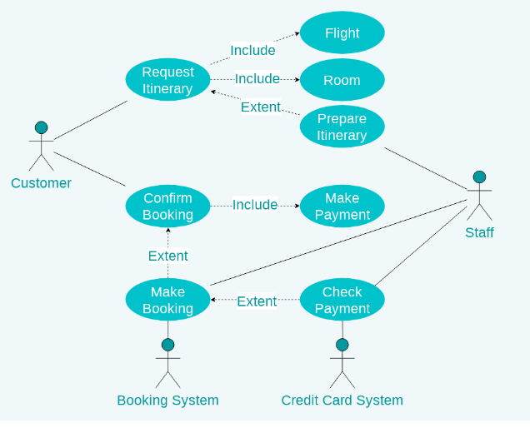

#### Use case diagram of our project

Hotel Detail

Ranking

Price Password

**View Hotel**

Calculator

Notepad

about

**Utilities**

**User**

**admin**

+opr_type

+free_number

+block_string

+opr_time()

+week period()

**Book hotels**

+patient_details

+problem_string

+age_string

+in_time()

+ot_time()

+*

Username Password Age ID

Email Phone No.

+1

Username

Password

Email Phone No.

**Customer**

Username

Password

Email Id

Phone No.

+*

**Destination**

Username Password days

Email Phone No.

**Package**

Package Detail

Ranking

Price Password

**Hotel**

Username Password

Email Phone No.

**Book Package**

Package Detail

Ranking

Price Password

**View package**

Package

Detail

Ranking

Price password

**Book hotel**

Hotel Detail

Ranking

Price Password

**Payment**

Billing Details amount tax discount

**Class Diagram**

### IMPLEMENTATION:

Implementing a comprehensive travel buddy Java-based project entails weaving together a multitude of intricate functionalities to deliver a seamless experience for both customers and administrators alike. At its core lies meticulous attention to detail in crafting modules that handle customer management and package details with finesse. From the customer’s perspective, the journey begins with a robust registration system, where they can effortlessly sign up by furnishing essential details such as name, email, and contact information.

Once registered, a secure login mechanism ensures authenticated access to their personalized profiles, wherein they can manage preferences and update information at their convenience. The package management module stands as the gateway to adventure, presenting an enticing array of travel packages meticulously curated to cater to diverse tastes and preferences. Here, customers can peruse through a rich tapestry of destinations, durations, costs, and itineraries, with search and filtering options enabling tailored exploration. Booking becomes a breeze as customers seamlessly transition from selection to reservation, with integrated payment gateways ensuring secure transactions and real-time payment status updates. Moreover, the booking management module empowers customers with the flexibility to modify or cancel bookings as needed, ensuring their journey remains as fluid as the destinations they seek to explore

### TESTING

The purpose of testing is to discover errors. Testing is the process of trying to discover every conceivable fault or weakness in a work product. It provides a way to check the functionality of components, subassemblies, assemblies and/or a finished product It is the process of exercising software with the intent of ensuring that the Software system meets its requirements and user expectations and does not fail in an unacceptable manner. There are various types of test. Each test type addresses a specific testing requirement.

#### Test Results:

All the test cases passed successfully. No defects encountered.

### SAMPLE SCREENSHOTS:

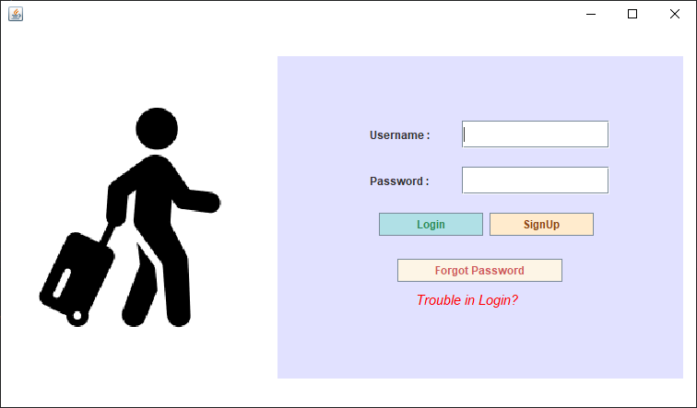

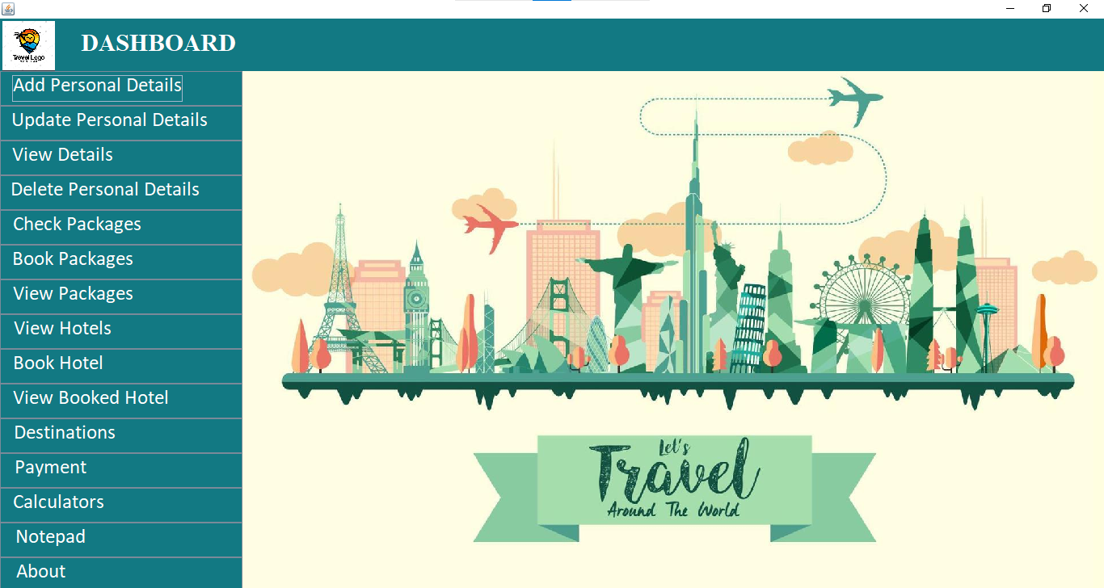

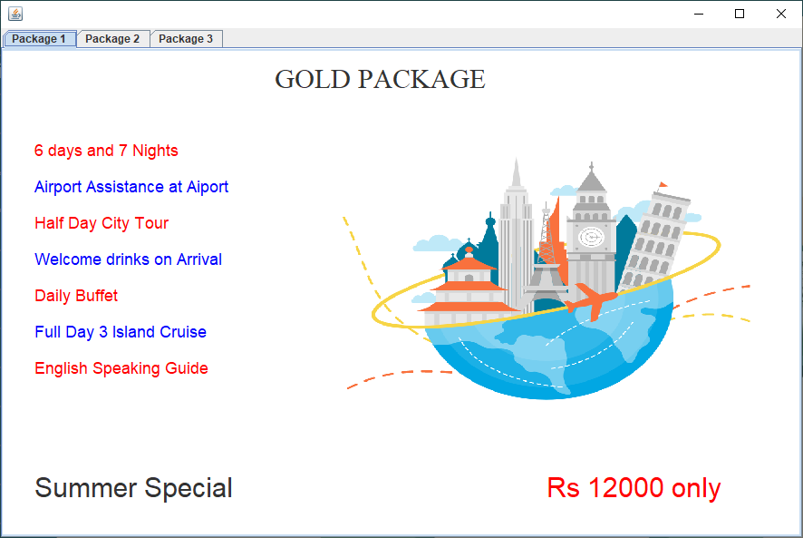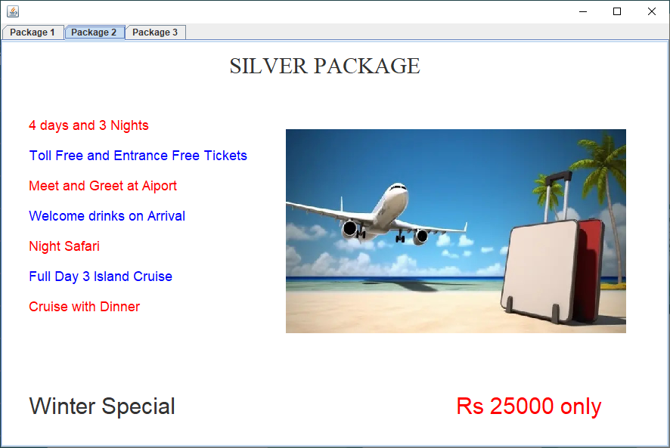

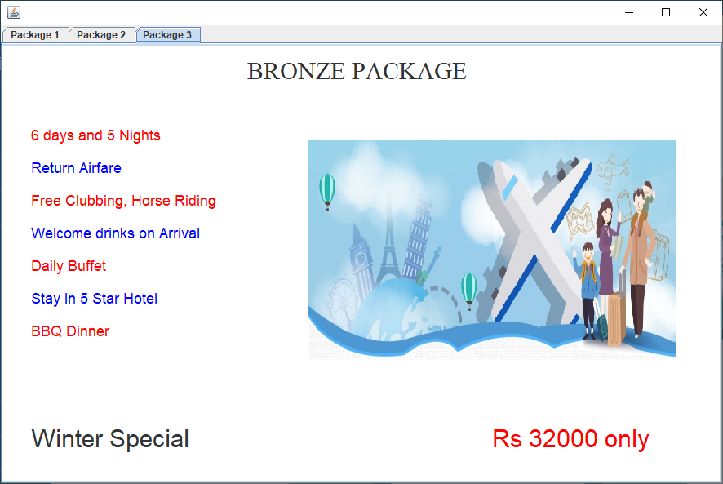

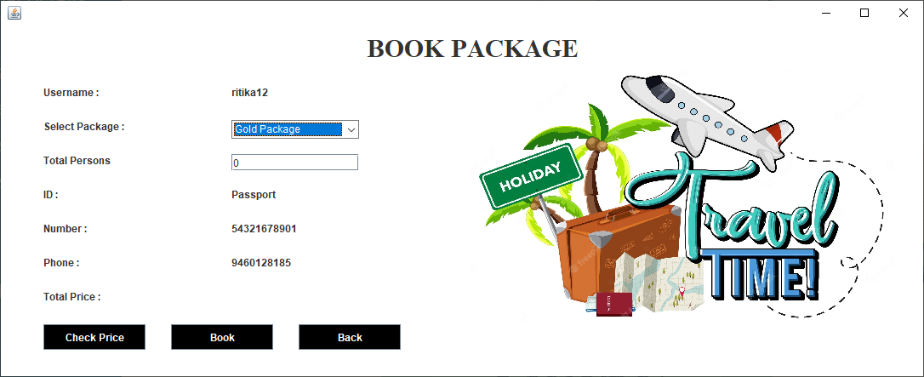

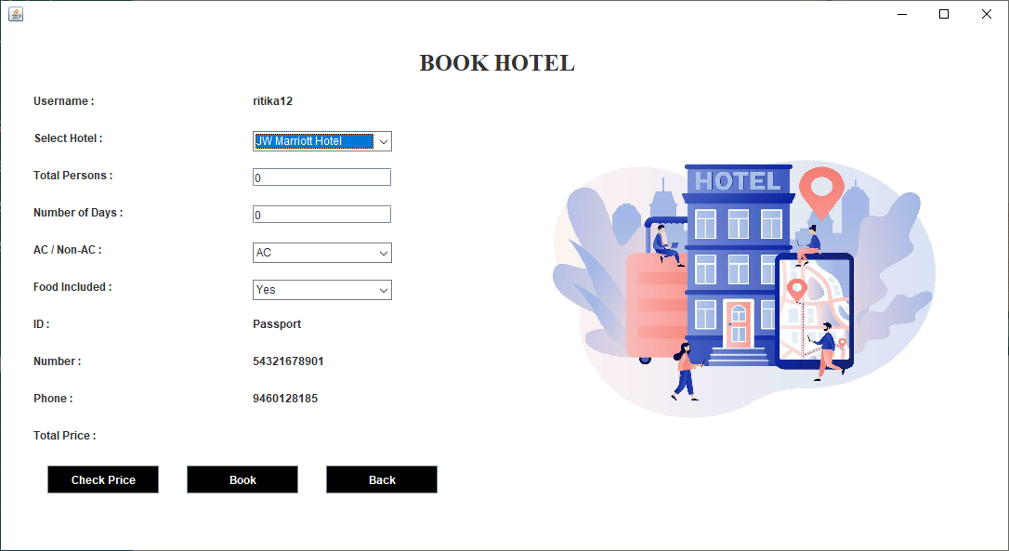

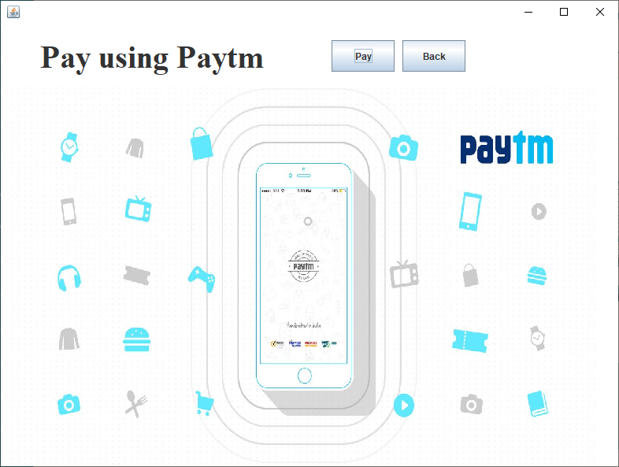

**CONCLUSION**

The growing quality demand in the hospital sector makes it necessary to exploit the whole potential of stored data efficiently, not only the clinical data, in order to improve diagnoses and treatments, but also on management, in order to minimize costs and improve the care given to the patients. Since we are entering details of the patients electronically in the” Hospital Management System”, data will be secured. Using this application we can retrieve patient’s history with a single click. Thus processing information will be faster. It guarantees accurate maintenance of Patient details. It easily reduces the book keeping task and thus reduces the human effort and increases accuracy speed.

**REFERENCES:**

* [**https://www.wikipedia.com**](https://www.wikipedia.com/)
* [**https://www.indiaToursOnline.com**](https://www.indiatoursonline.com/)
* [**https://www.realitytoursandtravel.com**](https://www.realitytoursandtravel.com)
* [**https://www.expedia.com**](https://www.expedia.com)
* [**https://www.booking.com**](https://www.booking.com)
* [**https://www.airbnb.com**](https://www.airbnb.com)
* [**https://www.travelocity.com**](https://www.travelocity.com)
* [**https://www.orbitz.com**](https://www.orbitz.com)